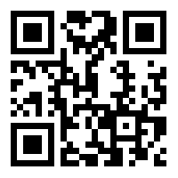
AJC INVESTMENT LTD
退貨或換貨表格EXCHANGE OR REPLACEMENT FORM
- 請填妥下到退貨/換貨表格 Please completed the Exchange or Replacement Form
- 將此表格連同貨品一同退回至本公司Include this slip in the parcel to be exchanged.
購買日期
Purchase Date
聯絡人姓名  Contact Person |  | 聯絡電話  Contact Number
訂單編號  Order Number |  | 商品名稱  Product Name
退換貨原因
Exchange/Replacement Reason(s)
付款方式
Payment Type
備註(如有)
Remarks (If any)

請注意 Please note:
- 客戶退回損壞的商品前，請先提供照片到info@swissskinexpert.com給我們確認。
Please send the photo of the damaged item to info@swissskinexpert.com for our confirmation before exchanging the product.
- 一張訂單只提供一次退換貨服務。Each form should be used for one order only.

本人已細閱及同意本公司AJC INVESTMENT LTD的退貨條款(http://www.swissskinexpert.com) 。
I have read and agree the Exchange or Replacement terms of AJC INVESTMENT LTD (http://www.swissskinexpert.com).

如有問題，歡迎至電+852 2687 6766或電郵至info@swissskinexpert.com 查詢。
If you have any questions, please call our customer service at +852 2687 6766 or e-mail to info@swissskinexpert.com

客戶簽署 Customer signature 日期 Date

_________________________ ___________________________
Name:

